Computation of Observer Position from Sight Lines to Three Known Landmarks

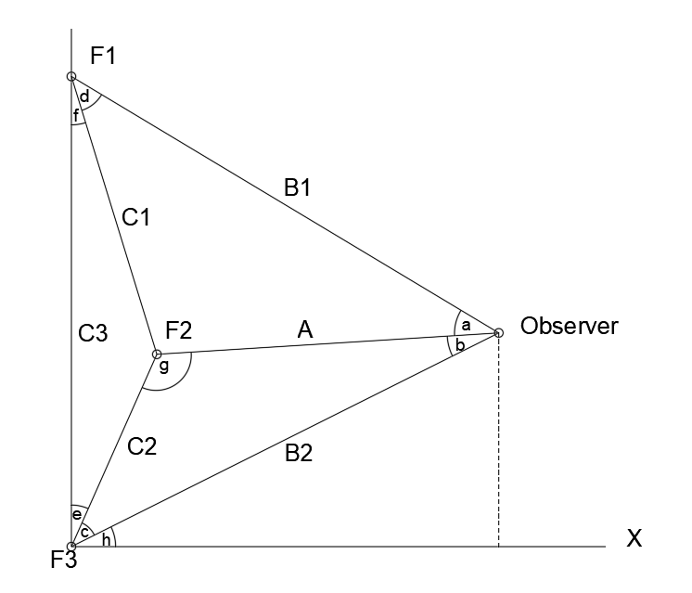

In the above diagram there is an observer (labeled Observer) and three fiducial landmarks (F1, F2, F3) at known positions. Angle *a* is formed by the observed sight lines to F1 and F2, angle *b* is formed by the observed sight lines to F2 and F3.

Sides C1, C2, and C3 are known and (importantly) the internal angles *e* and *f* of triangle C1C2C3 are also known. And, as already noted, angles *a* and *b* are known by observation.

For mathematical convenience, the determination of the observer’s position is performed in a coordinate system in which F3 is at the origin and F1 lies on the Y-axis. In this coordinate system, line B2 is the hypotenuse of a right triangle formed by B2, the X-axis, and a line extending from the observer to (and perpendicular to) the X-axis. Thus if the value of angle *h* and the length of line B2 can be determined, the observer position is known from the relationships of the right triangle.

Determination of the observer position relies on the “law of sines”, which can be stated as:

|  |  |  |
| --- | --- | --- |
|  | $$\frac{S1}{\sin\left(a1\right)}=\frac{S2}{sine\left(a2\right)}=\frac{S3}{\sin\left(a3\right)}$$ | (1) |

Where *S1*, *S2*, and *S3* are the sides of a triangle and *a1*, a2, *a3* are the opposing internal angles.

Start by using our know parameters to define two constant quotients:

$$CRatio1=\frac{C_{1}}{sin⁡(a)}, CRatio2=\frac{C_{2}}{sin⁡(b)}$$

Using the law of sines relationship, now create expressions for the length of *A* for triangles AB1C1 and AB2C2.

And

Combining these creates an expression that relates angles *c* and *d*.

|  |  |  |
| --- | --- | --- |
|  | $$d=arcsin\left(\frac{CRatio2*sin⁡(c)}{CRatio1}\right)$$ | (2) |

We also know that the sum of the angles of triangle B1B2C3 is Pi radians. Therefore:

|  |  |  |
| --- | --- | --- |
|  | $$π=a+b+d+f+e+c$$ | (3) |

Angles *a*,*b*,*e*,*f* are known, so for convenience we can combine them into a constant *k*.

|  |  |  |
| --- | --- | --- |
|  | $$k=a+b+e+f$$ | (4) |

Substituting (4) into (3) and rearranging gives:

|  |  |  |
| --- | --- | --- |
|  | $$d=π-(k+c)$$ | (5) |

Combining equations (2) and (5) gives a relationship that can be solved for *c*:

$$π-\left(k+c\right)= arcsin\left(\frac{CRatio2*sin⁡(c)}{CRatio1}\right)$$

And finally, solving for *c:*

|  |  |  |
| --- | --- | --- |
|  | $$c=-arctan\left(\frac{CRatio1*sin⁡(k)}{CRatio1*\cos\left(k\right)-CRatio2}\right)$$ | (6) |

Having uniquely determined angle *c*, we note that angle *g* (the angle formed by lines A and C2) and angle *h* (formed by line B2 and the X-axis) are now also uniquely determined as:

$$g=π-\left(b+c\right), h=\frac{π}{2}-(e+c)$$

Applying the law of sines on more time allows us to determine the length of line B2:

The observer position is thus:

$$x_{obs}=B_{2}*\cos\left(h\right), y_{obs}=B_{2}*\sin\left(h\right)$$

Two issues slightly complicate this calculation. First, note that, as drawn in the example sketch, point F2 lies between the observer and triangle base C3.  This is an arbitrary feature of the example; F3 might well be more distant from the observer and lie on the other side of the line between points F1 and F3. In this latter case, angles *e* and *f* as used in the equation for *k* above are effectively negative and thus must be subtracted from, rather than added two, *k*. To determine the relative position of F2, it is necessary to translate and rotate F2 in a manner that would (if applied to F1 and F3) to cause F3 to lie at the local coordinate system origin, and F1 to lie on that coordinate system’s positive Y-axis. Note that this rotation also places base C3 on the Y-axis. If the resulting X-axis coordinate of F2 is positive, then angle *e* and *f* are positive; otherwise, they are negative,

The second issue arises from the appearance of the arctan function in equation (6) above. Not only does the evaluation of the argument risk division by zero, but also the range of the function is $-\frac{π}{2}<c<\frac{π}{2}$, thus rendering the result ambiguous if $c>\frac{π}{2}.$ In computer code, the proper technique is to use the two argument “atan2” function:

|  |  |  |
| --- | --- | --- |
|  | $$z=-atan2(CRate1*\sin\left(k\right), CRatio2*\cos\left(k\right)-CRatio2)$$ | (7) |

The result of function (7) requires further interpretation because an angle “wrap” occurs when angle *c* increases beyond $π/2$– the result *z* transitions from a negative angle in the 3rd quadrant to a positive angle in the 1st quadrant. The following pseudo code provides the correct angle *c*.:

If (z < 0) then

c = PI +z

Else

c = z

End